**Department of Electrical and Computer Engineering**

**San Francisco State University**

**Fall 2024**

**Final Project Report on ASIC Implementation of Motion Estimator in 14nm Finfet Technology Presented by**

|  |  |
| --- | --- |
| **Name** | **SFSUID** |
| SeyedParsa Mirfasihi | 923636204 |
| Vyshnavi Shekhar Byrapatna Somashekhar | 923840668 |

Under the guidance of

Dr. Hamid Mahmoodi

Department of ECE

San Francisco State University

**Table of Contents**

Problem Analysis.................................................................   
Hardware Design.................................................................  
Verification..........................................................................  
Synthesis..............................................................................  
PhysicalDesign....................................................................  
Sign-Off...............................................................................  
Discussion............................................................................  
Conclusion...........................................................................

* **Objective:** The objective of this project is the RTL2GDSII implementation of Motion Estimator design used for lowering data size while retaining video quality in video compression in cutting-edge 14nm Finfet technology.
* 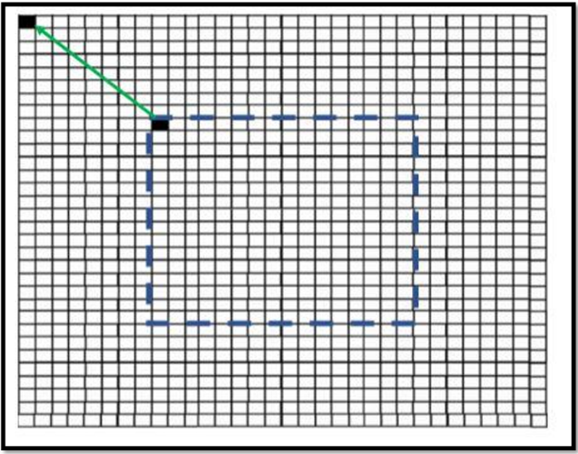Design Specifications:
* 16x16 Reference Block
* 31x31 Search Window
* Grey-scale coded pixels
* Clocks available : 1 GHz
* 14nm Finfet library

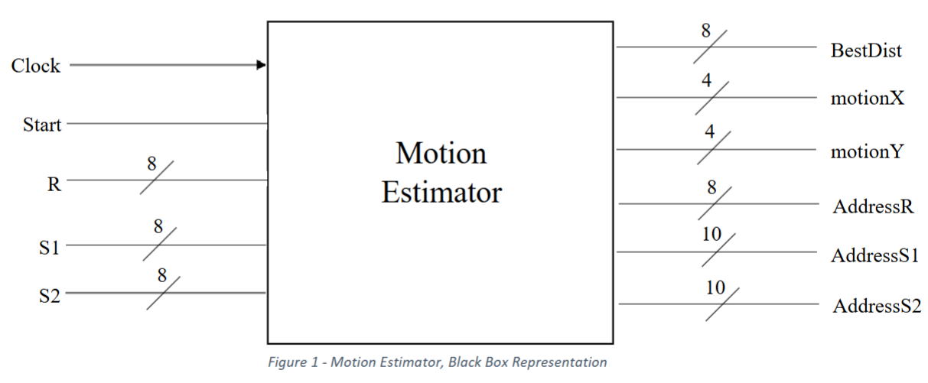

**Memory Elements:**

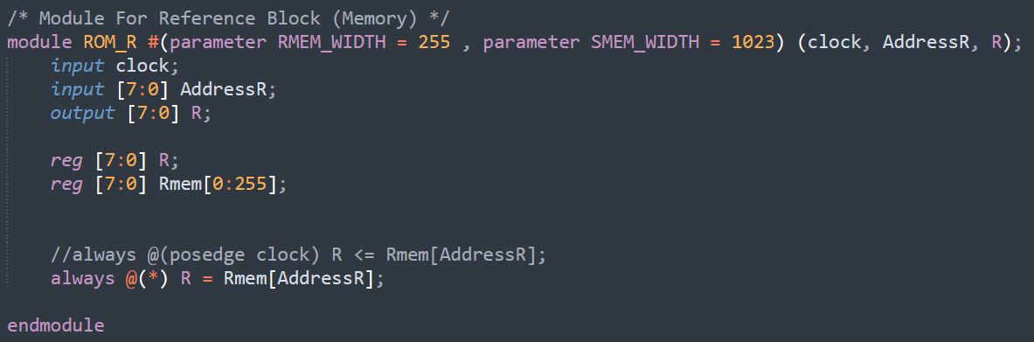

**Module ROM_R:**

This module defines a simple Read-Only Memory (ROM) block in Verilog, specifically for a reference block in a digital system. The module has two parameters, inputs, and an output:

**Parameters:**

1. **RMEM_WIDTH** (default = 255): Sets the width (or address range) of the ROM, indicating the number of memory locations available.
2. **SMEM_WIDTH** (default = 1023): This parameter appears in the definition, but it's unused within the code. It could be reserved for future functionality or as part of an unused specification.

**Ports:**

1. **clock** (input): This input is currently not used in the code but may be intended for synchronization in future development.
2. **AddressR** (input [7:0]): An 8-bit input address for accessing specific memory locations within the ROM.
3. **R** (output [7:0]): An 8-bit output that provides the data stored in the ROM at the specified address.

**Internal Registers:**

1. **R** (reg [7:0]): Temporarily holds the data value corresponding to the specified address. However, it's declared as reg in the code but is not used for storage since the always block directly assigns R to the output.
2. **Rmem** (reg [7:0] Rmem [0:255]): An 8-bit wide, 256-location ROM array that holds the memory contents. Each element in this array corresponds to a memory address, allowing 256 different 8-bit data values to be stored.

**Functionality:**

The always block is sensitive to any changes (indicated by @(*)) in the inputs, meaning it will execute whenever AddressR changes. In this block:

* The output R is assigned the value stored in Rmem at the address specified by AddressR. This enables read-only access to the ROM data.

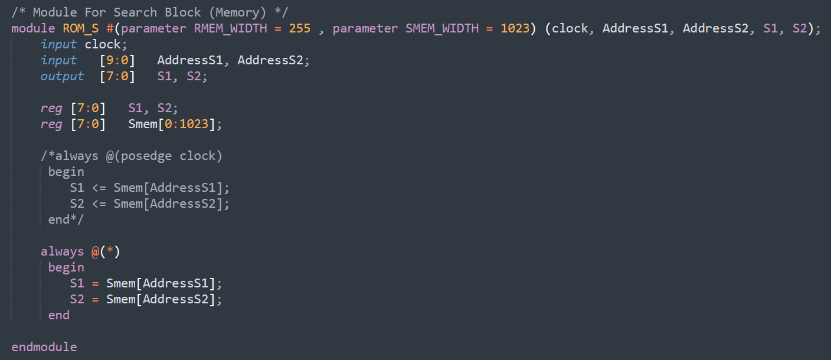

**Module ROM_S:**

This module defines a memory block used for a search operation in a digital system, likely a ROM-based design. It includes two parameters, several inputs and outputs, and an internal memory array.

**Parameters:**

1. **RMEM_WIDTH** (default = 255): Specifies the width (or address range) of the ROM, representing the maximum addressable memory locations.
2. **SMEM_WIDTH** (default = 1023): Defines the width of a separate memory segment but appears unused in this specific code.

**Ports:**

1. **clock** (input): Although the clock signal is defined, it is not currently used within the code. It might be intended for future development to synchronize read operations.
2. **AddressS1, AddressS2** (input [9:0]): 10-bit input addresses used to access specific memory locations. With 10-bit addressing, this module can theoretically access up to 1024 locations.
3. **S1, S2** (output [7:0]): These 8-bit outputs represent the data retrieved from memory locations specified by AddressS1 and AddressS2.

**Internal Registers:**

1. **S1, S2** (reg [7:0]): Temporarily holds the data output from the memory at the specified addresses. However, these are directly assigned to outputs and are used to reflect the memory values in real-time.
2. **Smem** (reg [7:0] Smem [0:1023]): An 8-bit wide, 1024-location ROM array to store the memory contents. Each element in Smem represents a memory location, allowing storage of 1024 distinct 8-bit data values.

**Functionality:**

The always block is sensitive to any changes in the inputs (indicated by @(*)), meaning it will execute whenever AddressS1 or AddressS2 changes. Within this block:

* S1 is assigned the value stored in Smem at the address specified by AddressS1.
* S2 is assigned the value stored in Smem at the address specified by AddressS2.

This enables the module to perform two independent read operations simultaneously, allowing S1 and S2 to output data from different memory locations.

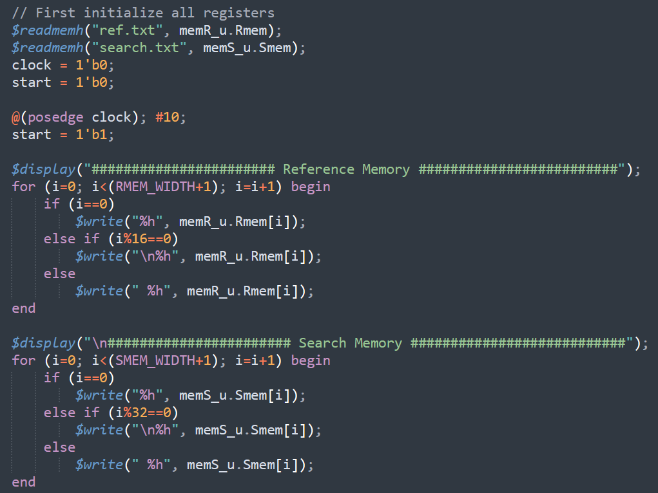

**Memory Elements:**

* Result is imported from MobaXterm

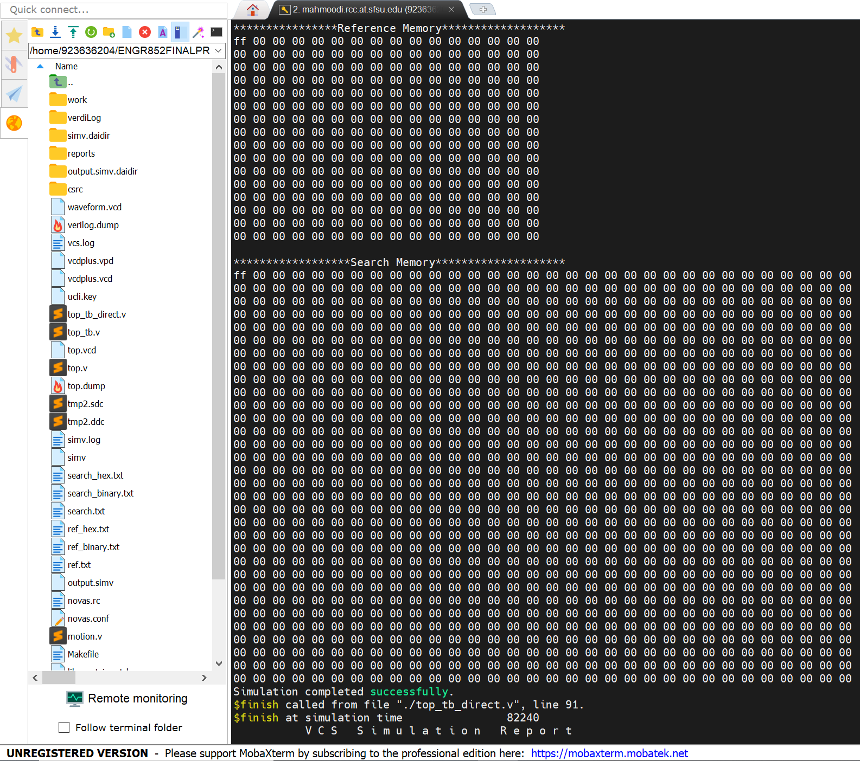

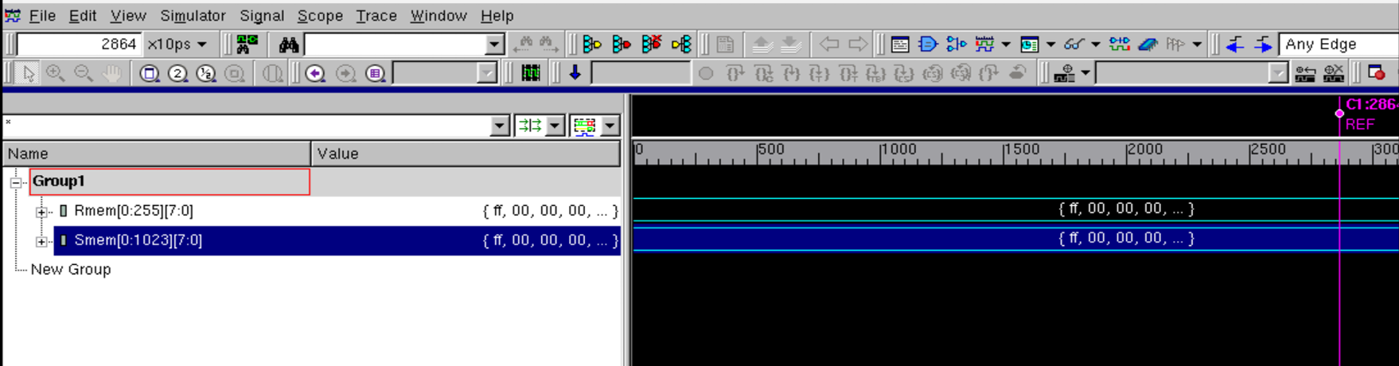

**Processing Elements:**

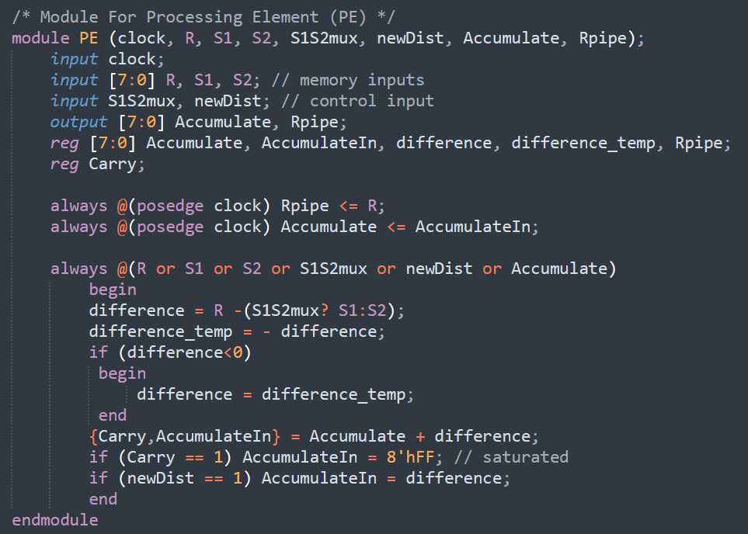

**Module PE (Processing Element):**

This module defines a Processing Element (PE), a fundamental unit in many hardware designs for processing data. It operates on input data, performs arithmetic operations, and accumulates results based on control signals. This module is particularly structured to support operations involving two memory inputs and an accumulation process.

**Ports**

1. **Inputs**:

* **clock**: Clock signal for synchronous operations within the module.
* **R** (input [7:0]): An 8-bit input data from memory (possibly a reference value).
* **S1, S2** (input [7:0]): Two 8-bit inputs, which are memory values for processing.
* **S1S2mux**: Control signal to select between S1 and S2.
* **newDist**: Control signal to reset the accumulation.

1. **Outputs**:

* **Accumulate** (output [7:0]): Holds the accumulated result after processing.
* **Rpipe**: A pipelined register for storing the value of R for the next clock cycle.

**Internal Registers**

1. **Accumulate** (reg [7:0]): Used internally to store accumulated results.
2. **AccumulateIn** (reg [7:0]): Temporary register to hold intermediate accumulation values.
3. **difference** and **difference_temp** (reg [7:0]): Used to store the calculated difference between R and the selected input (S1 or S2).
4. **Carry**: Used for overflow detection during addition in accumulation.

**Functionality**

The module contains three main always blocks that control the flow of data and operations:

1. **Pipeline Register Update**:

* Rpipe is updated with the value of R on each positive edge of clock. This provides pipelining, allowing R to be delayed by one clock cycle for future use.

1. **Accumulation Register Update**:
   * Accumulate is updated with AccumulateIn on each positive edge of clock, ensuring that accumulation is synchronized with the clock signal.
2. **Combinational Logic for Processing**:
   * This block is triggered whenever any relevant inputs change. It performs the following steps:
     + **Difference Calculation**: The module calculates the difference between R and either S1 or S2, based on the value of S1S2mux. If S1S2mux is 1, S1 is selected; otherwise, S2 is selected.
     + **Absolute Value**: If the difference is negative, difference_temp is used to store the positive equivalent, ensuring that only the absolute difference is accumulated.
     + **Accumulation**: AccumulateIn is updated by adding the calculated difference to the current accumulated value. The result also considers Carry to handle overflow.
     + **Saturation**: If Carry is 1, indicating overflow, AccumulateIn is set to 8'hFF, representing the maximum value (saturated result).
     + **Reset Condition**: If newDist is 1, AccumulateIn is reset to the current difference, starting a new accumulation.

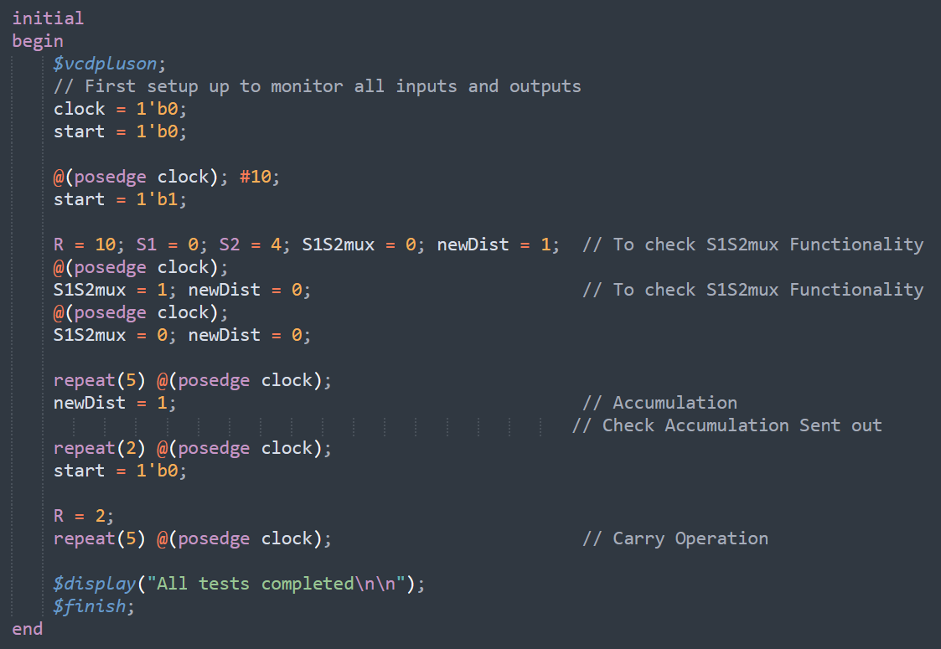

* Result is imported from MobaXterm

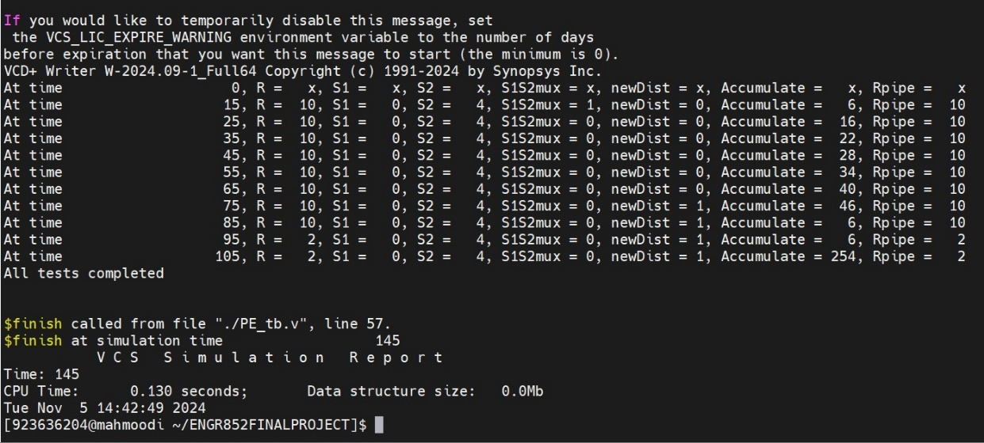

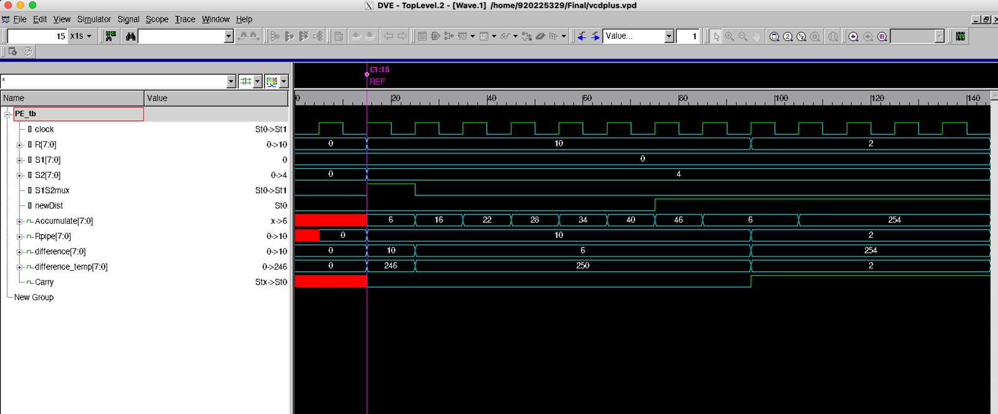

**PROCESSING ELEMENT TOTAL(PETOTAL):**

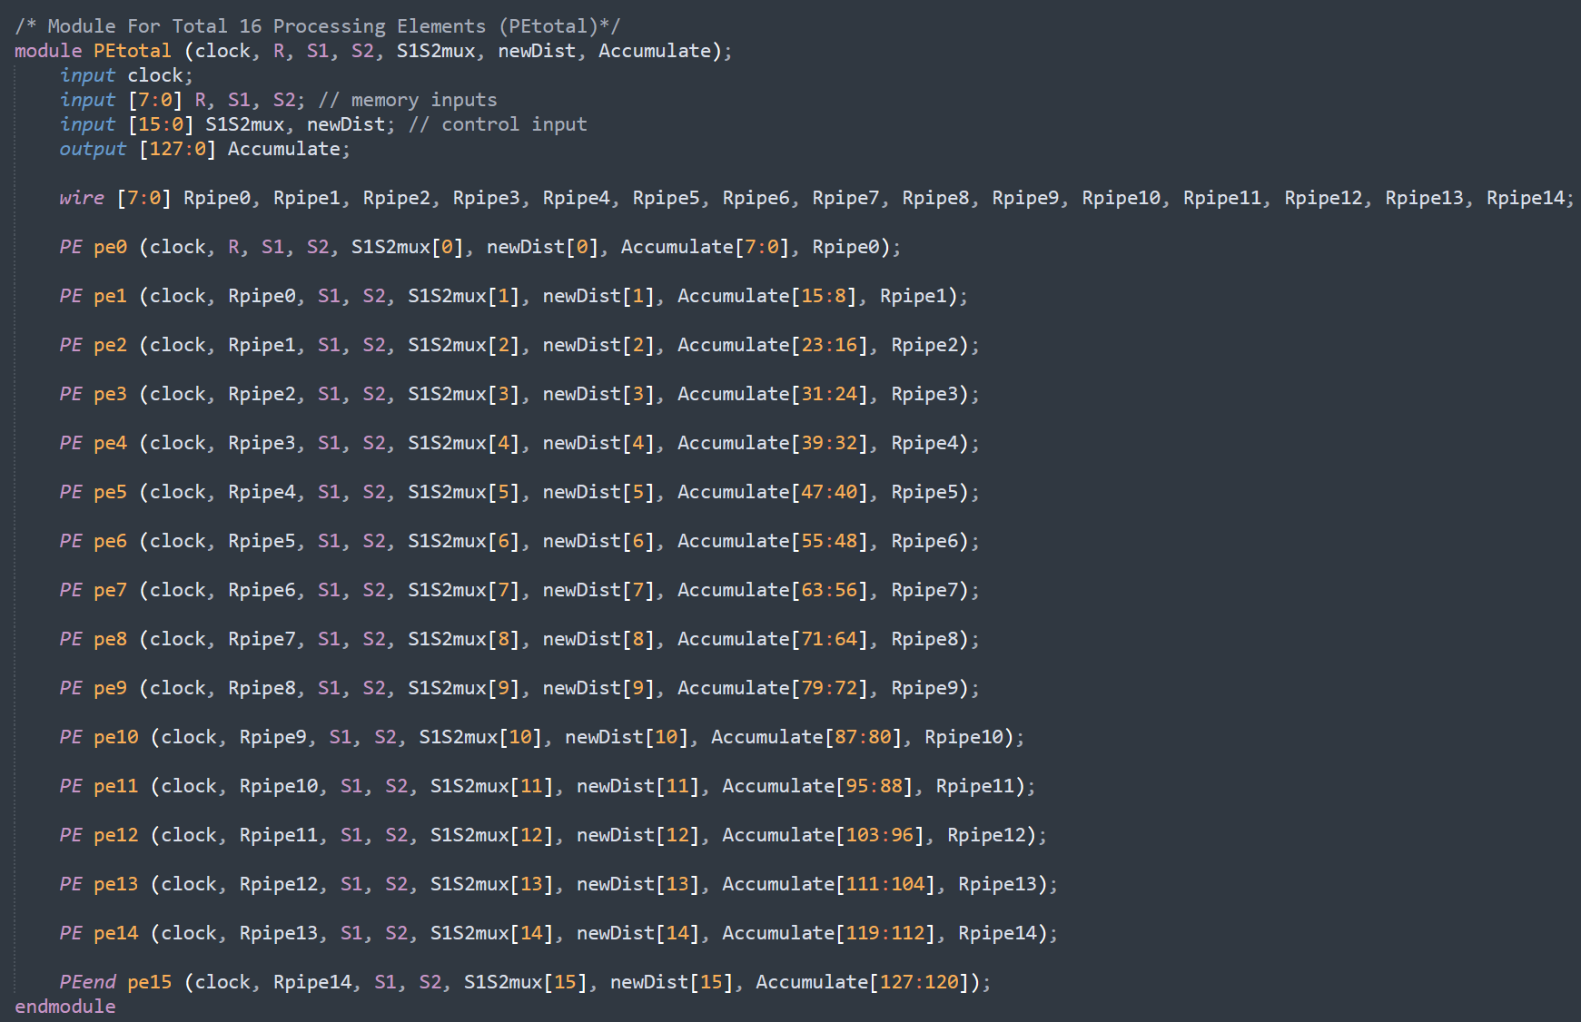

**Module PETOTAL:**

The PETotal module defines a system with 16 Processing Elements (PEs). Each PE is instantiated with specific inputs and outputs, which together form the complete PETotal structure.

**Key Components:**

**Inputs**:

* clock: A clock signal for synchronization.
* R, S1, S2: Control or configuration signals.
* S1S2mux and newDist: 16-bit control input arrays used to provide values to each PE module.

**Outputs**:

* Accumulate: A 128-bit wide output that collects results from each of the 16 PEs.

**Internal Wiring**:

* Rpipe[0:15]: An array of 8-bit wires that connect between various PEs, likely used to pass data from one PE to another in a pipelined structure.

**PE Instantiation:**

Each PE (Processing Element) is instantiated with specific arguments:

* Each PE receives the clock, R, S1, and S2 signals.
* Each PE instance connects to a unique S1S2mux and newDist input (e.g., S1S2mux[0], newDist[0] for PE pe0).
* The Accumulate output is split into 8-bit chunks, with each PE writing to a distinct segment of this 128-bit output.

This configuration appears to implement a parallel processing structure where each PE performs operations on the S1S2mux and newDist inputs, and their results are accumulated in the Accumulate output.

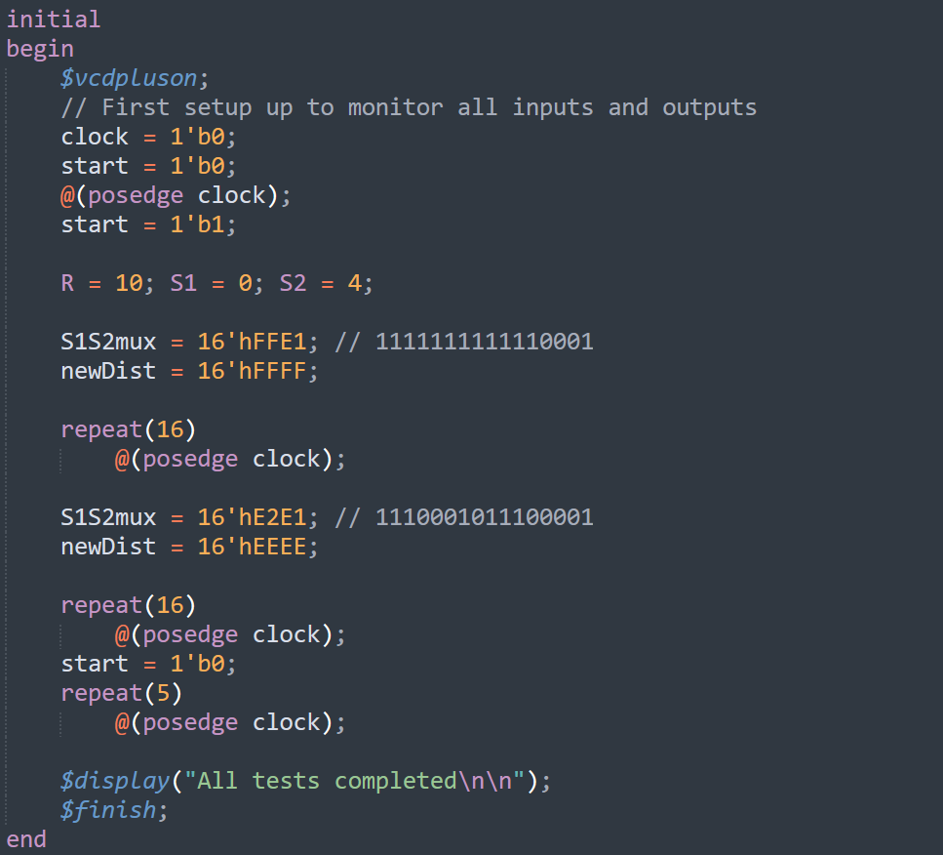

* Result is imported from MobaXterm

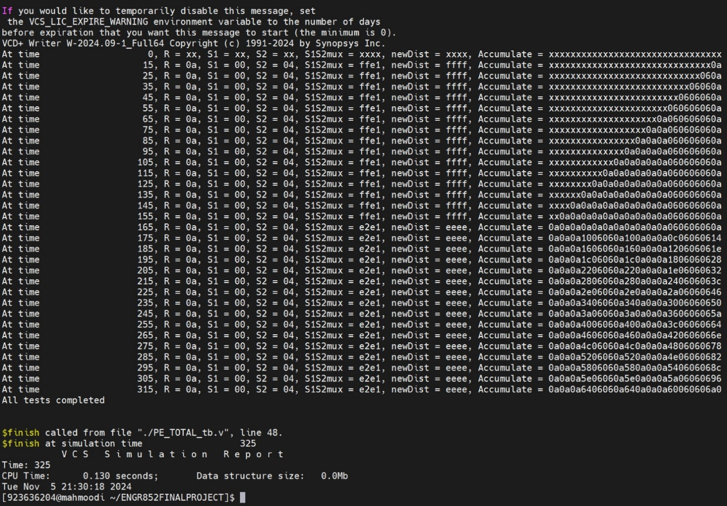

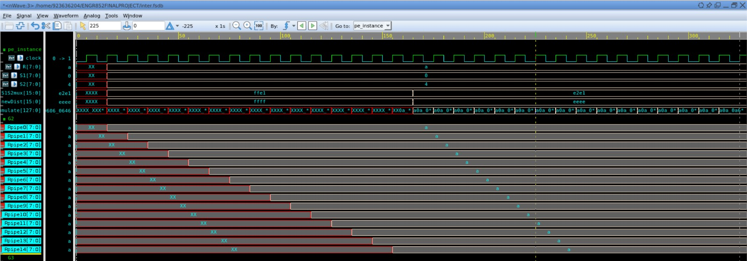

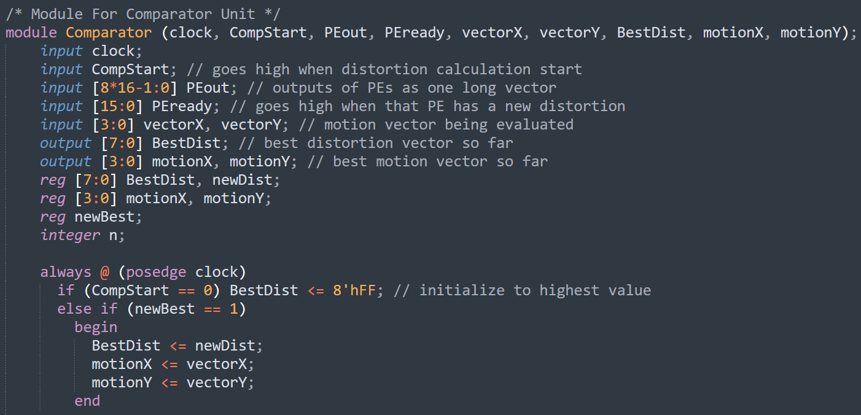**Comparator Unit:**

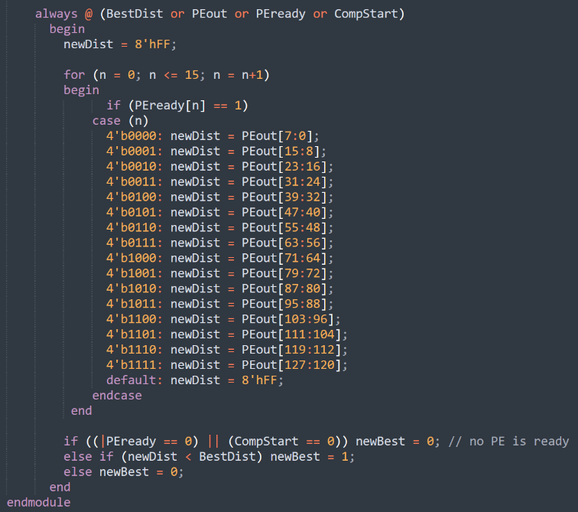

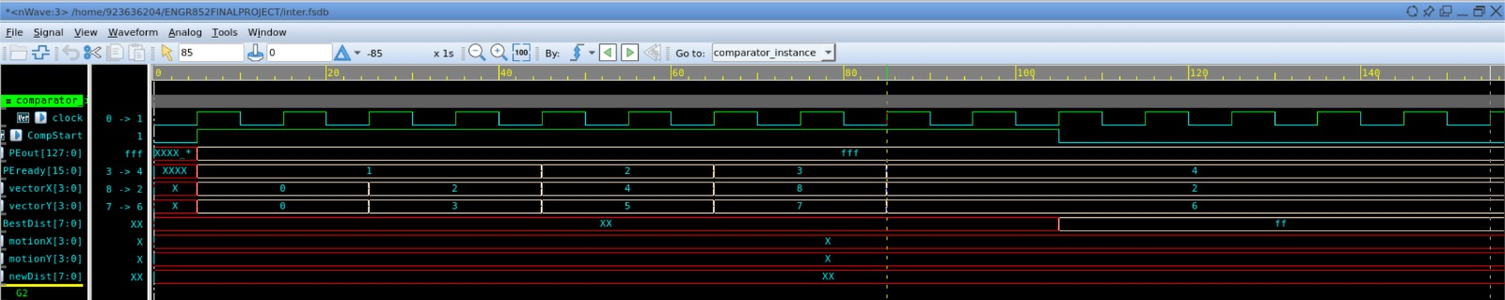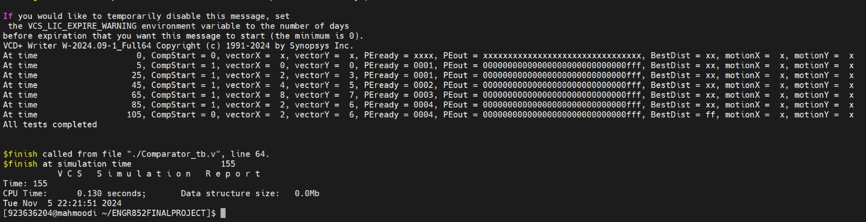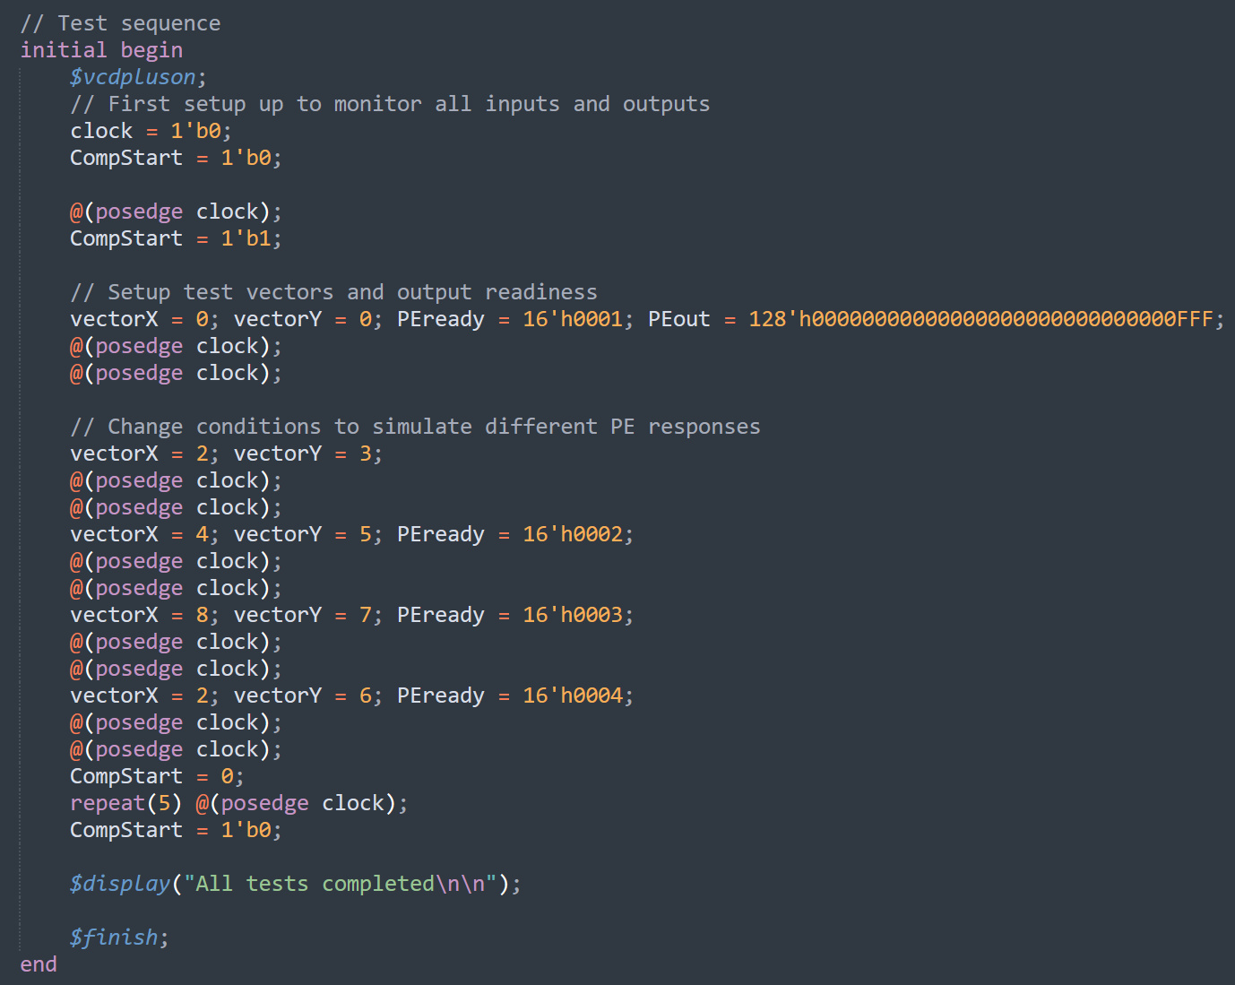

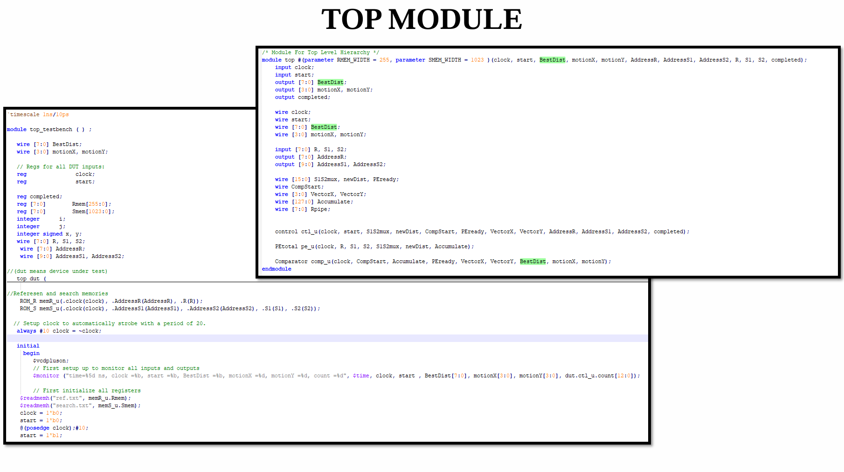

**Timing Analysis:**

**HOLD**

**SETUP**

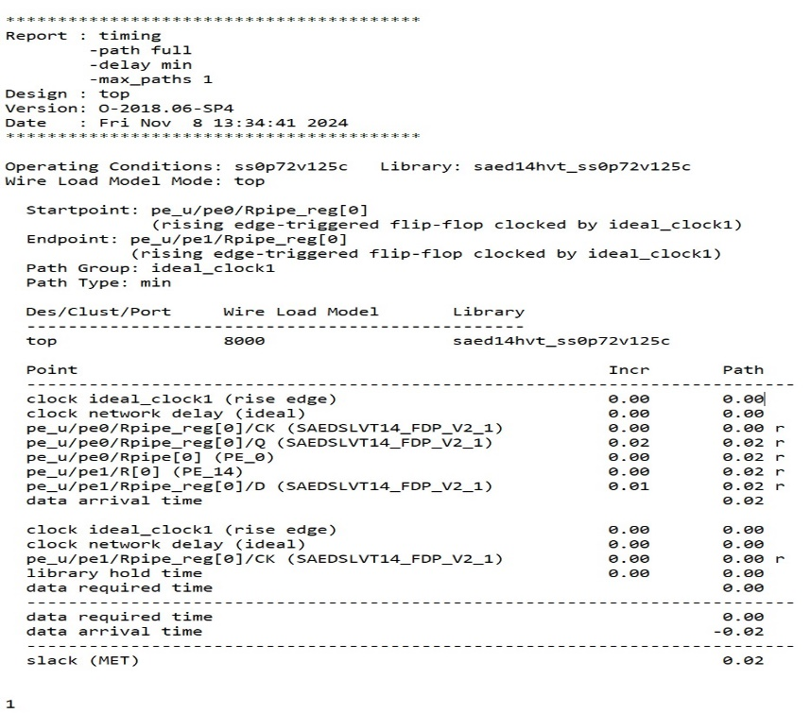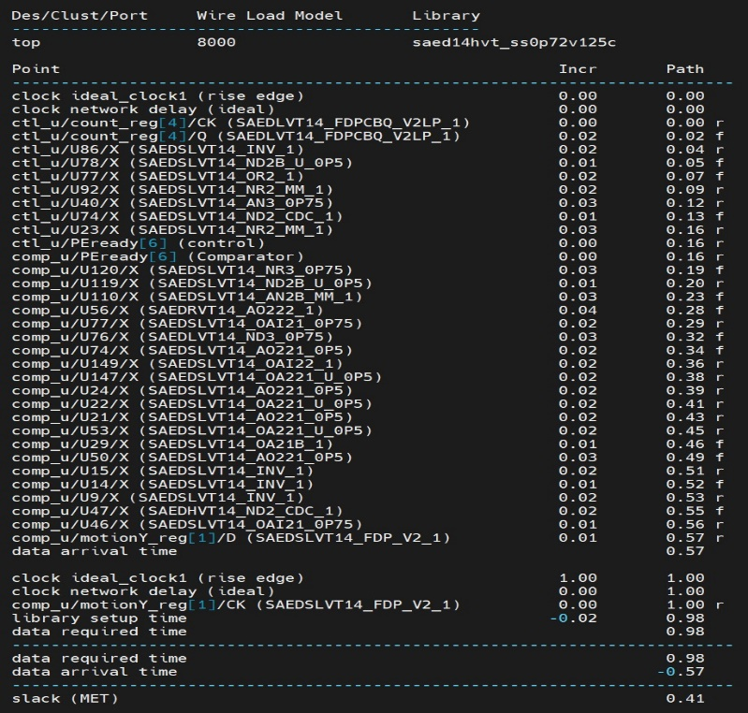

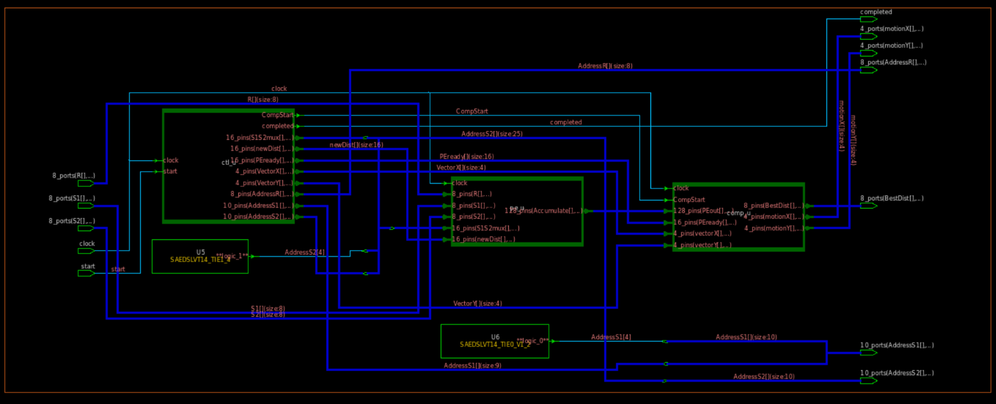

Comparator Module

Processing Element

Control Unit

**Schematic View**

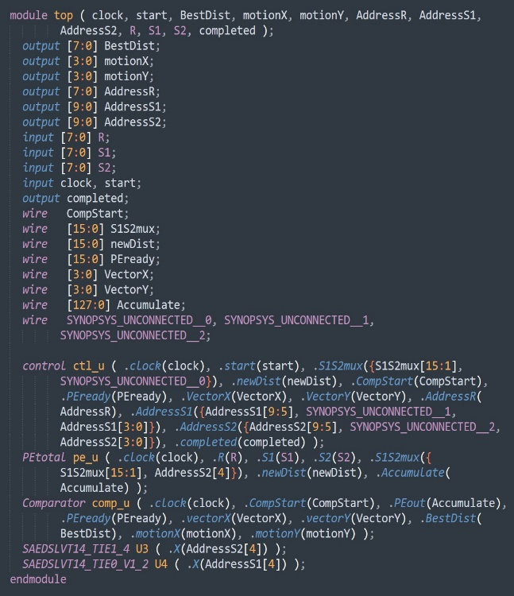

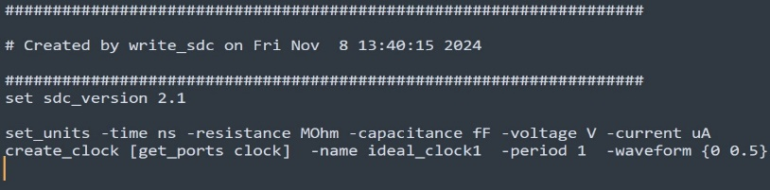

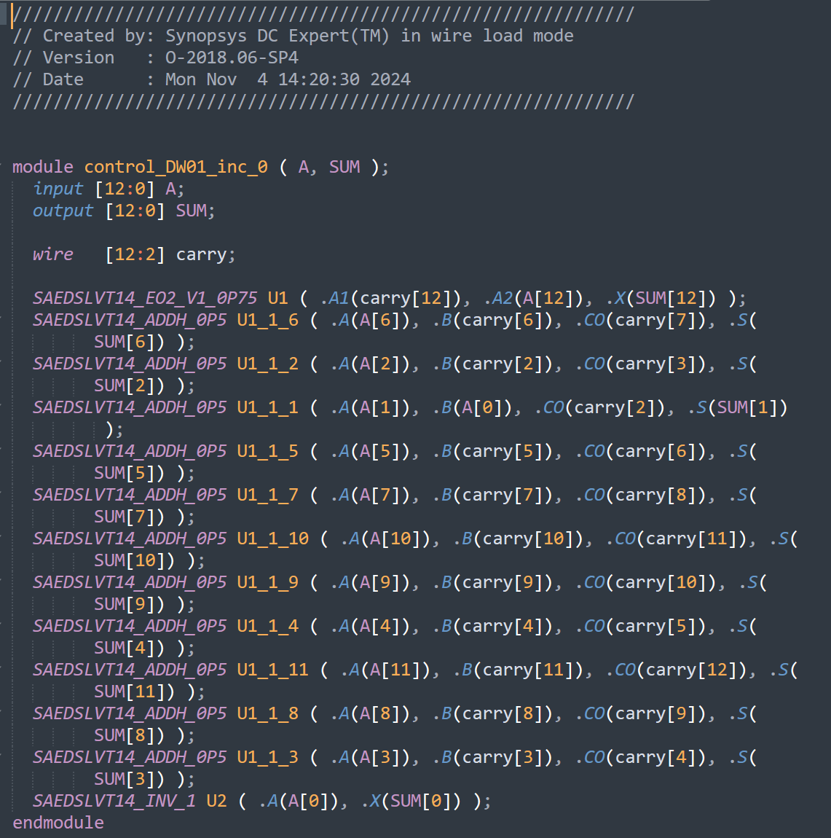

**SDC Constraints**

**Gate-level Netlist**

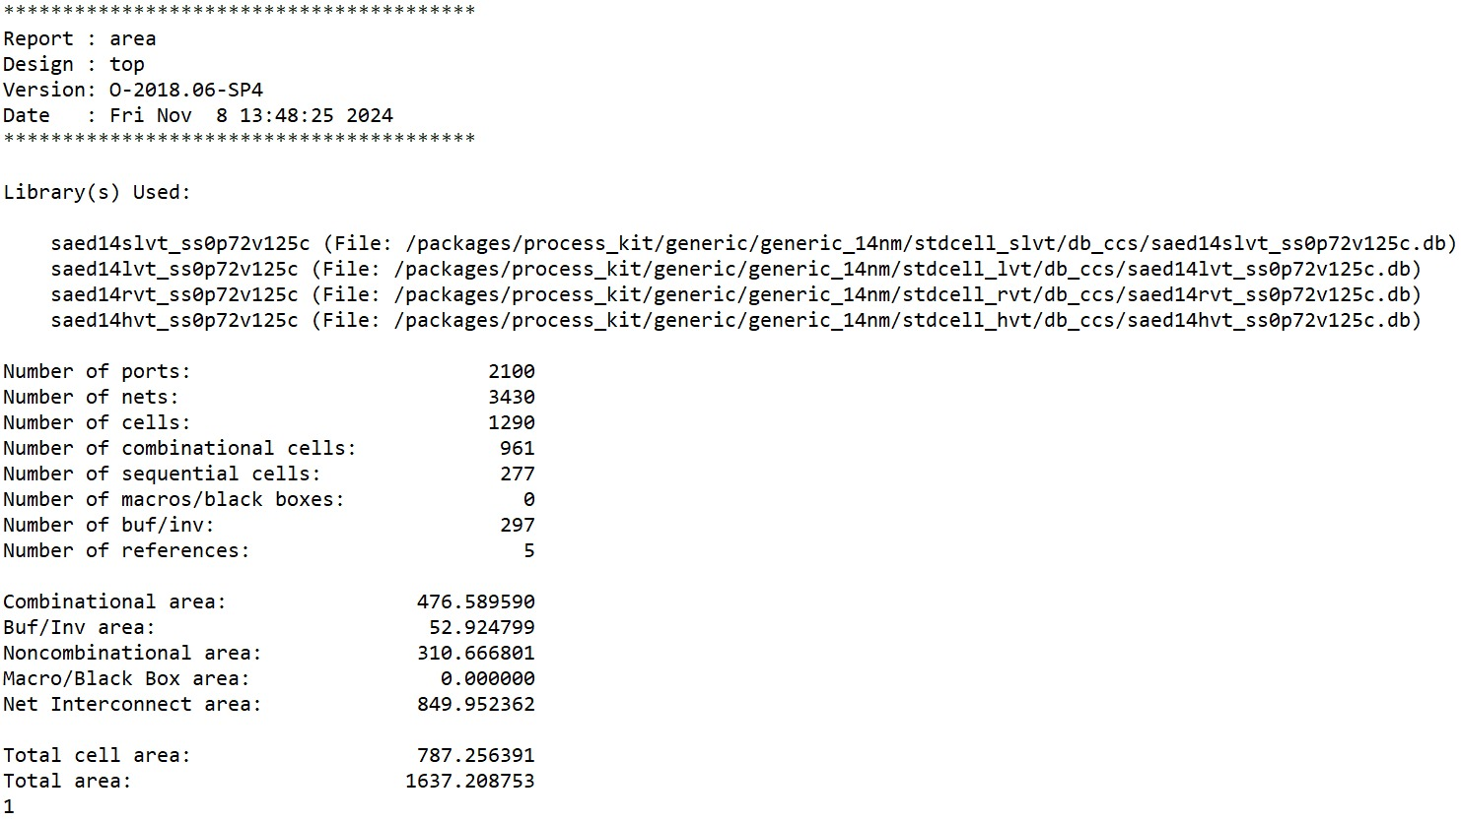

**Area Report**

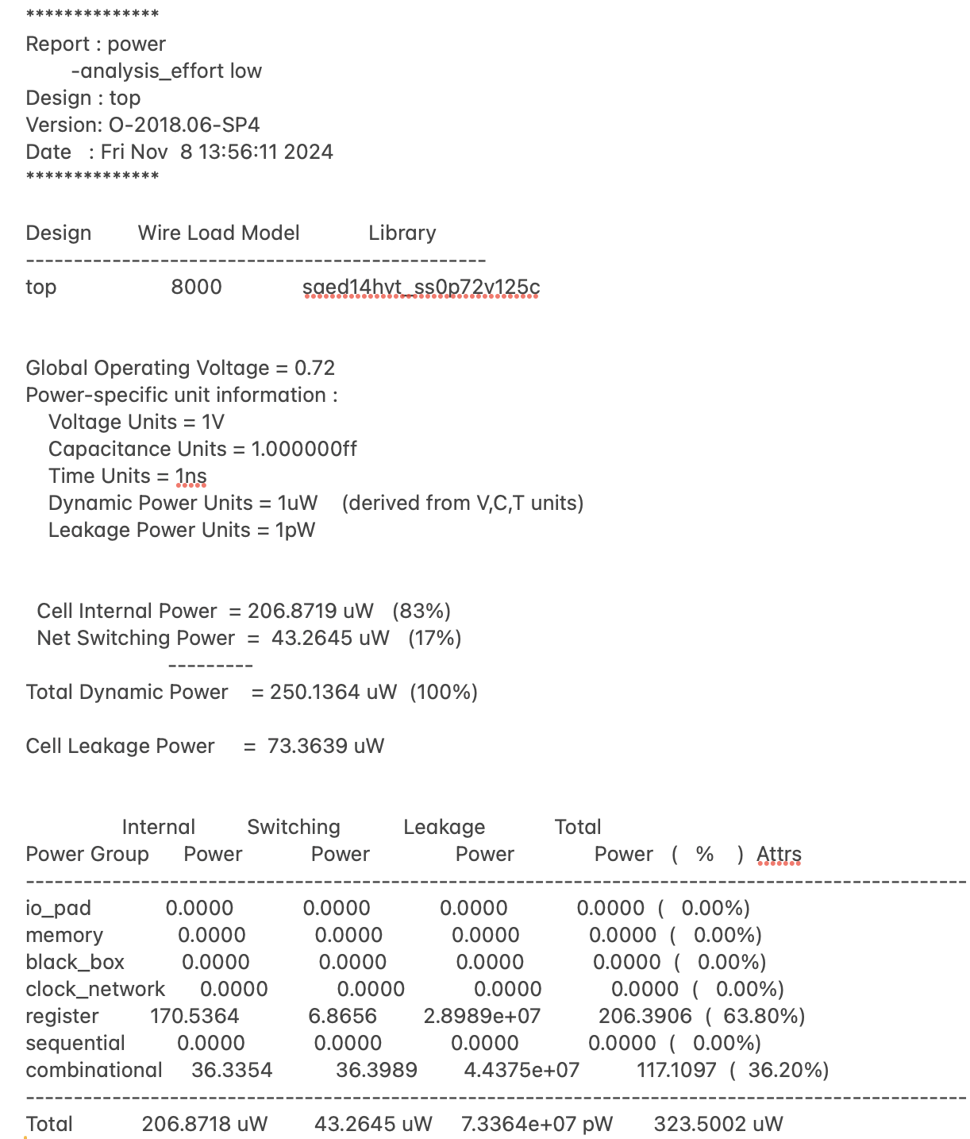

**Power Report**

**Physical Design:**

**- Layout view**

The displayed layout is the post-placement and routing phase in the physical design process. It shows the arrangement of standard cells, nets, and clock trees on a silicon die.

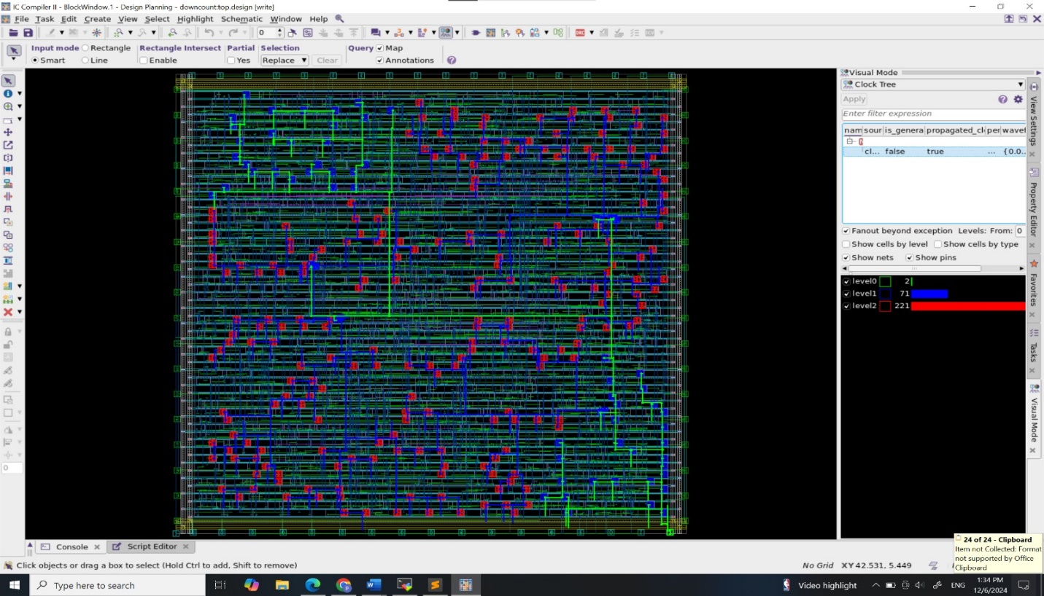

**- Clock Tree Synthesis (CTS)**: Checking clock signal propagation across different levels.

- **Routing and Congestion Analysis**: Identifying high-density areas where routing congestion or delays might occur.

- **Timing Closure and Power Analysis**: Ensuring timing constraints and low power requirements are met.

**Complete Physical Design:**

* **Flow consists of:**
  + Partitioning

Clock Tree

* + Floor Planning
  + Placement
  + Routing

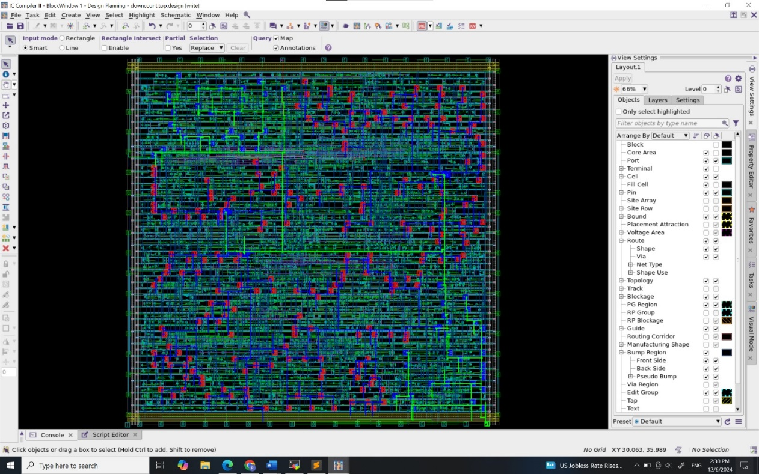

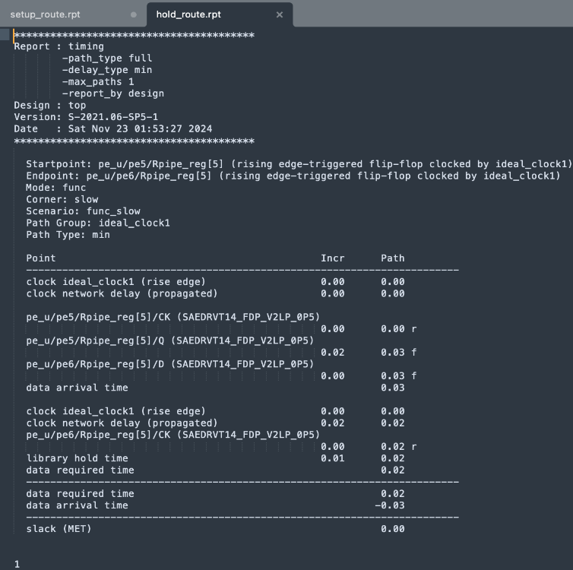**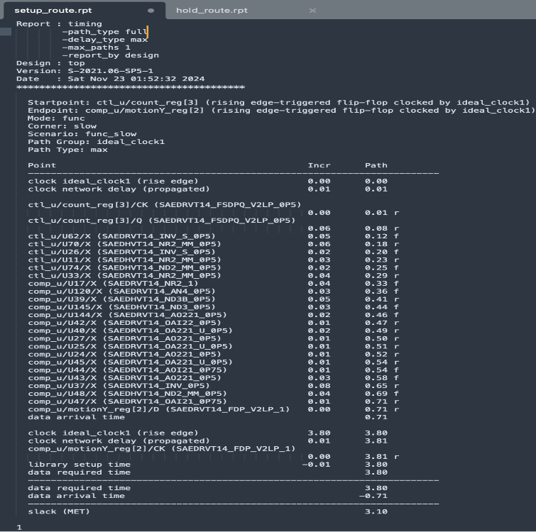Physical Design Timing Report:**

Hold

Setup

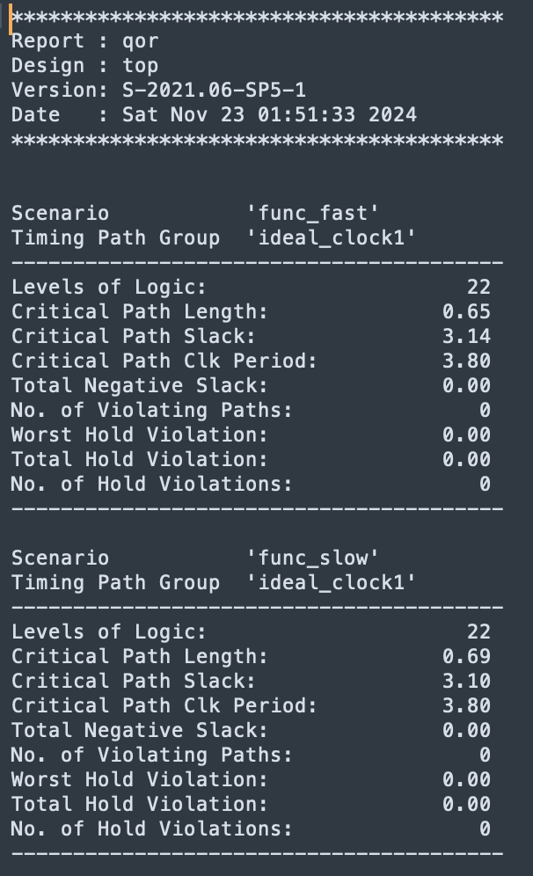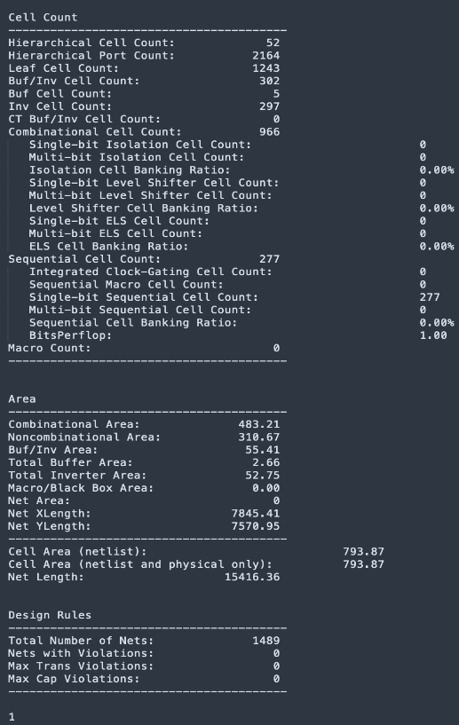**QoR and Utility Report:**

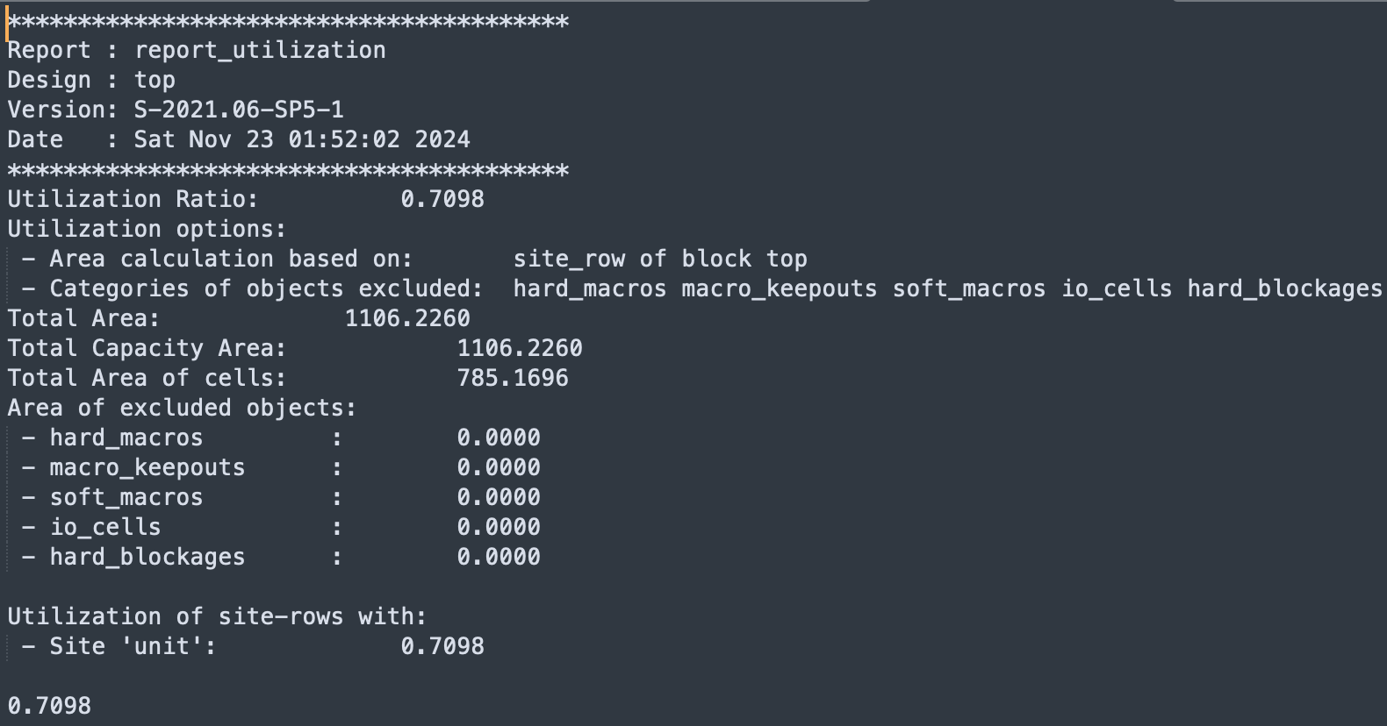

**1. QoR Analysis:**

Both func_fast and func_slow corners meet all timing constraints, with no violations. The design is timing-optimized with sufficient slack in both corners.

**2. Utility Report:**

The design utilizes approximately 71% of the available area, indicating efficient placement with room for optimization or expansion.

No excluded regions or hard/soft blockages simplify routing and minimize congestion.

**Physical Design Power and Area:**

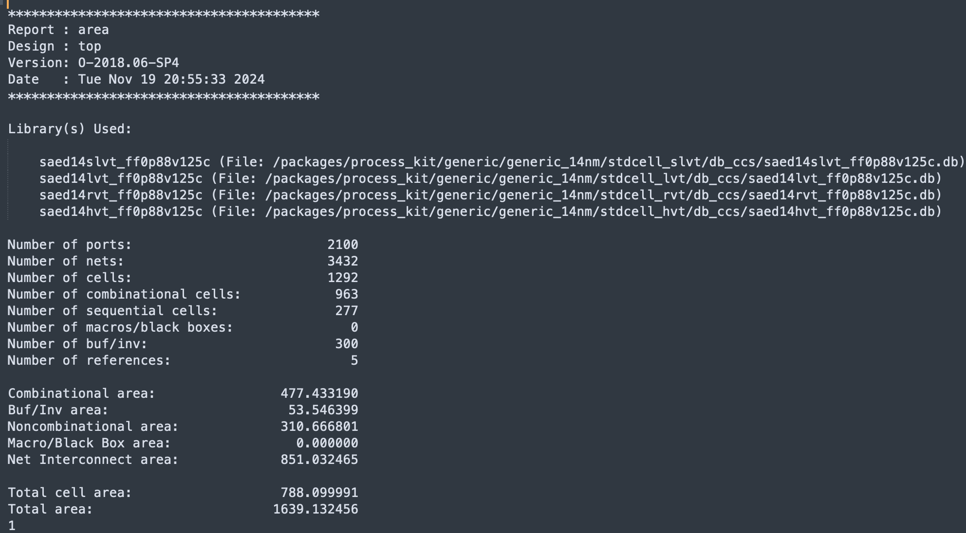

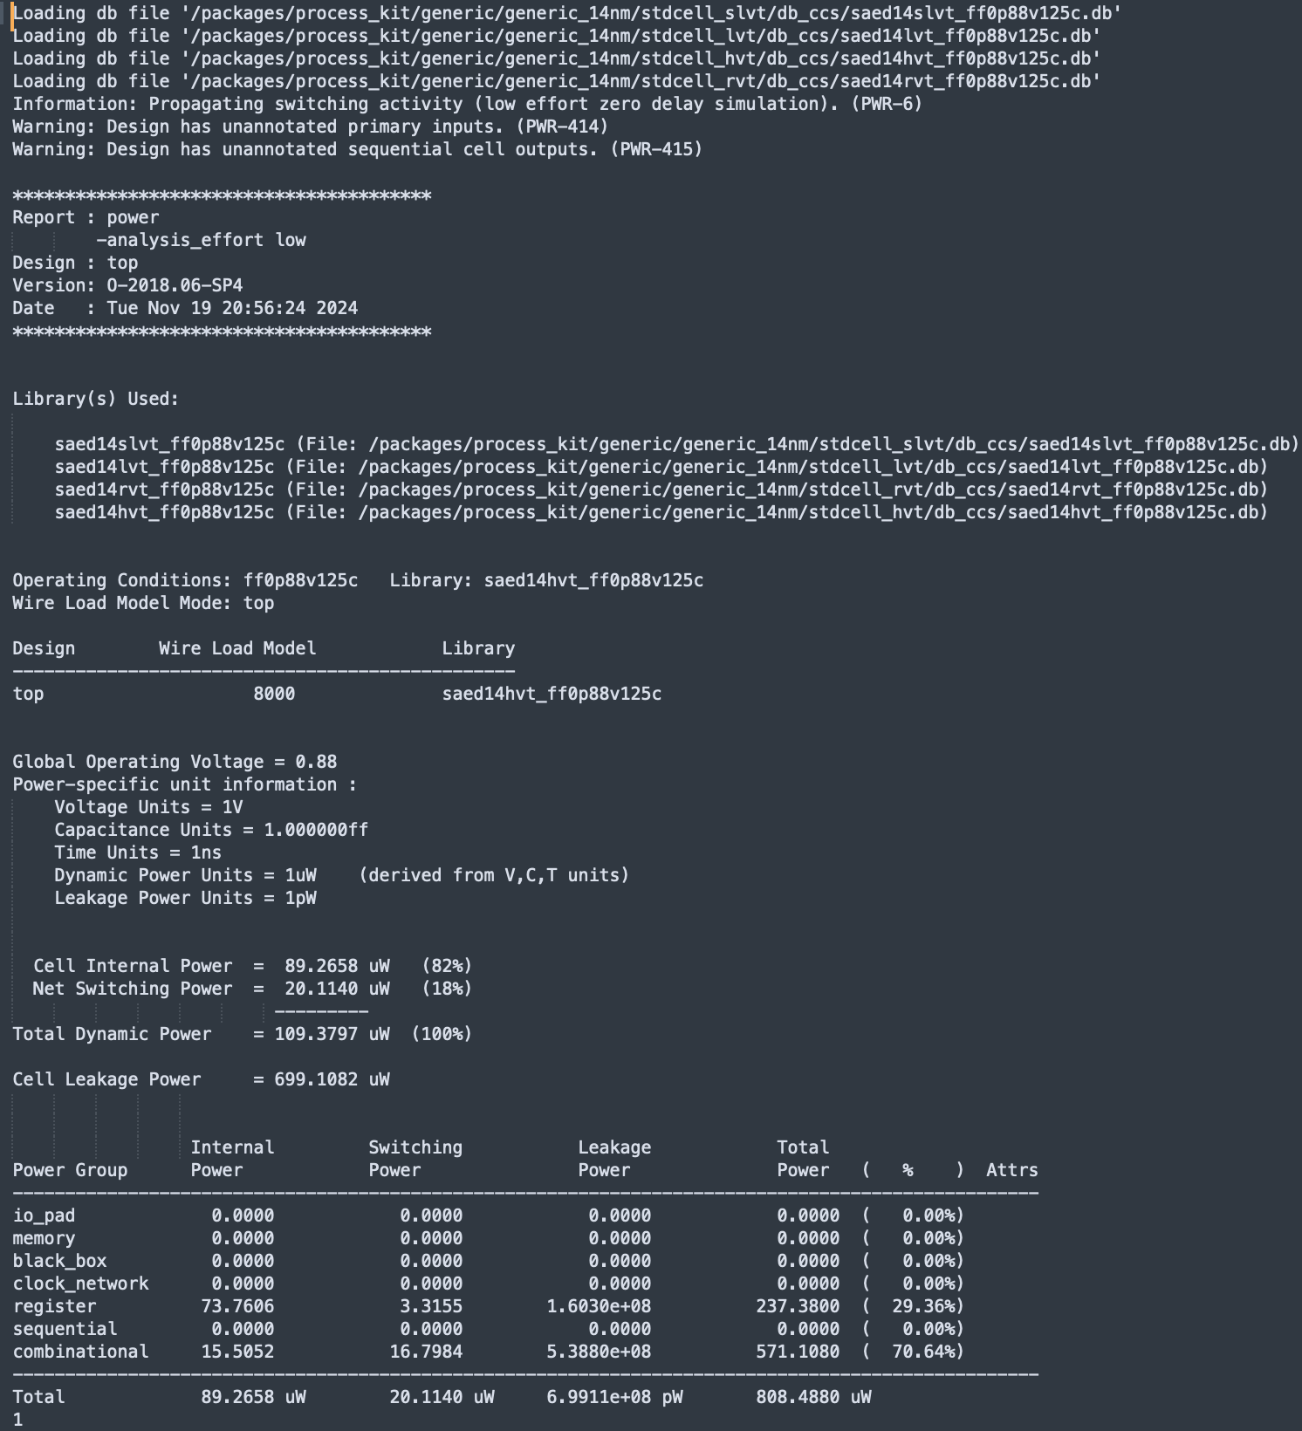

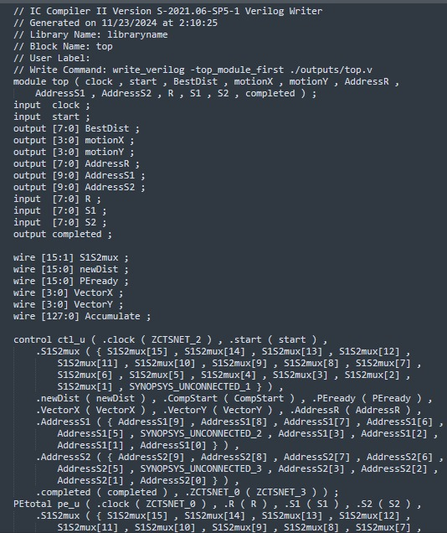**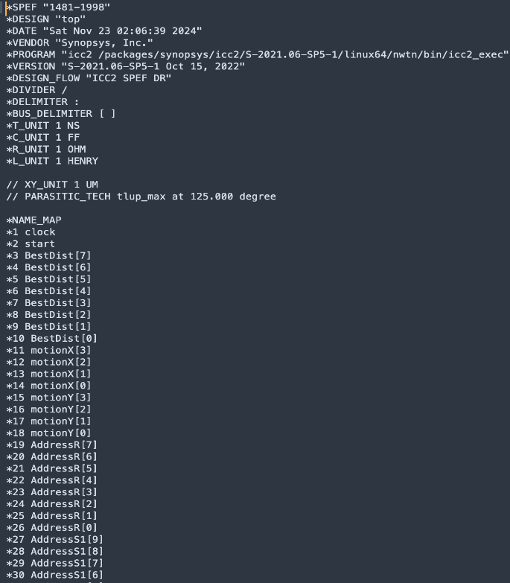Physical Design Parasitic and Netlist:**

Netlist

Parasitic File

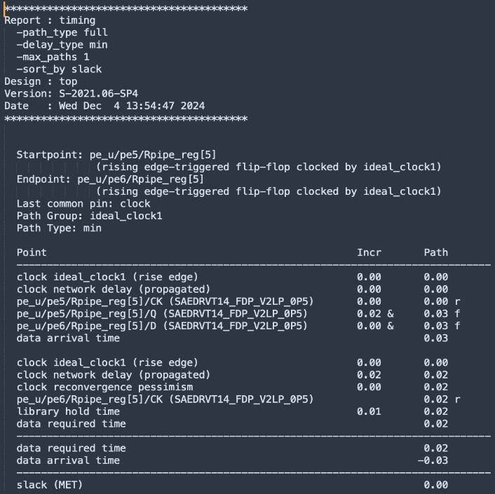**Post-Layout Timing Verification Using Prime-Time:**

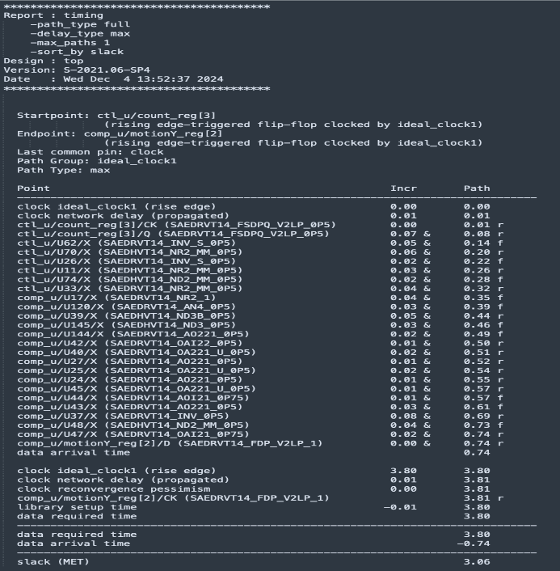

Hold

Setup

***Thank you***